ETL Stream test pipeline from Flask to Postgres

Mock api

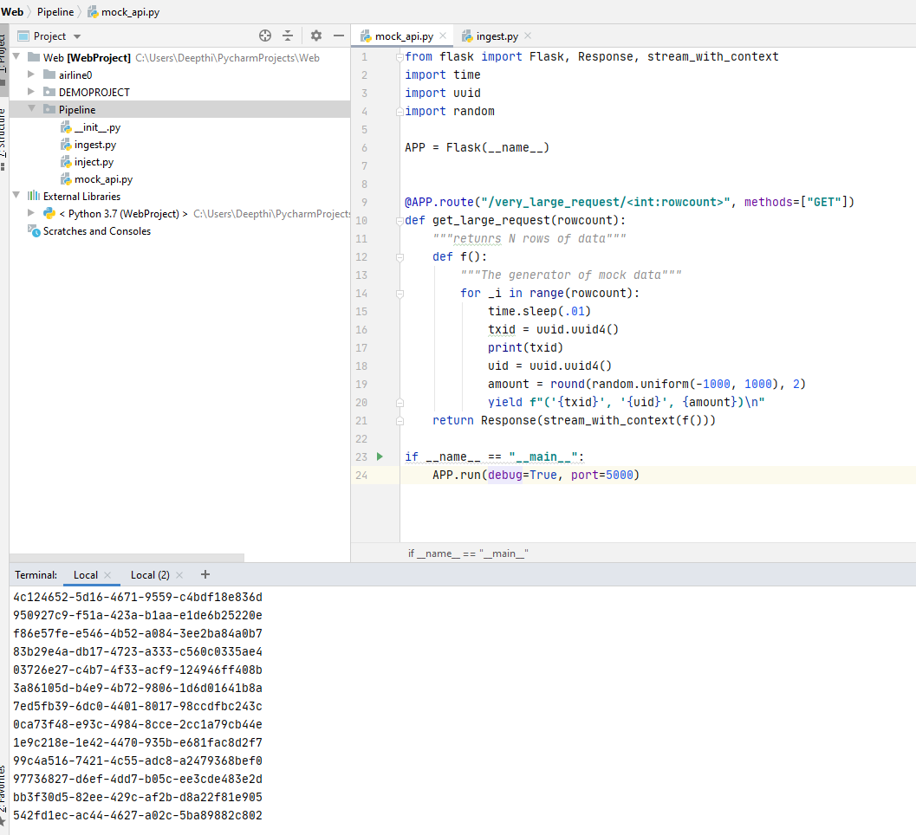

Verify mock api on browser for data for 1000 reords:

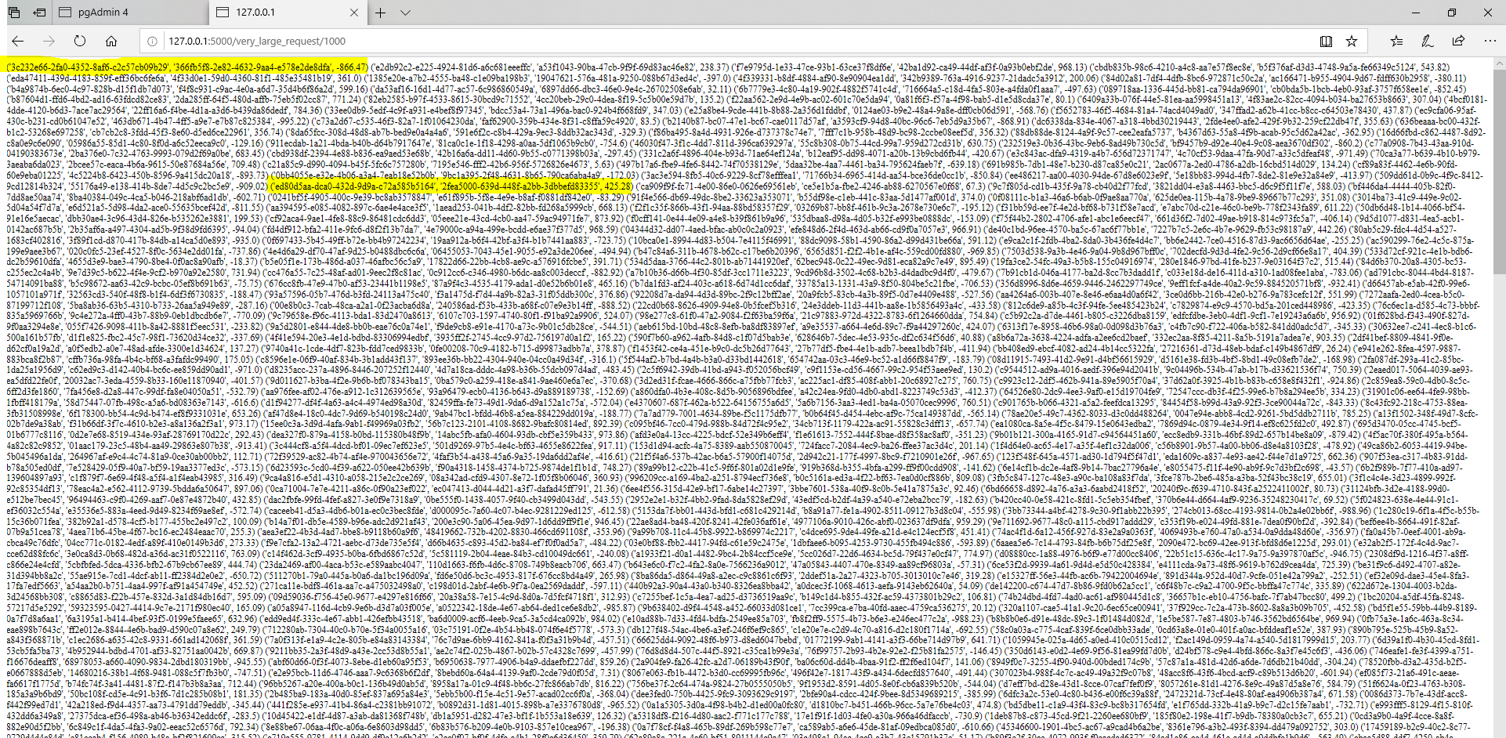

Create a database in postgress where we can push the data:

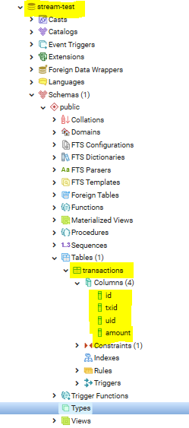

Here id is primary key.

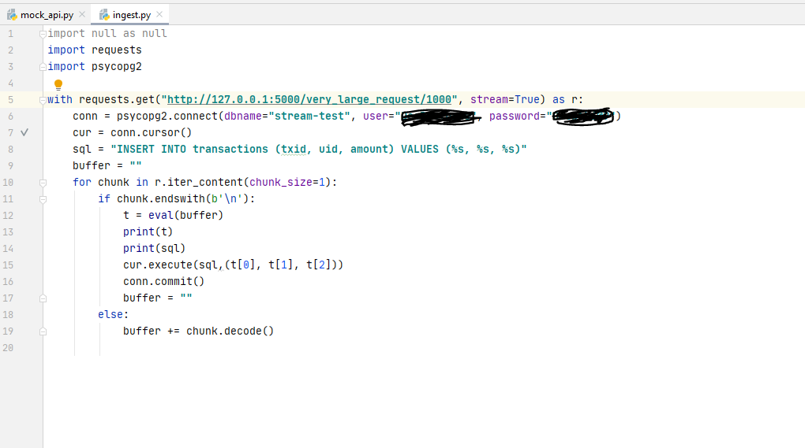

Execute the code and records are inserted as below:

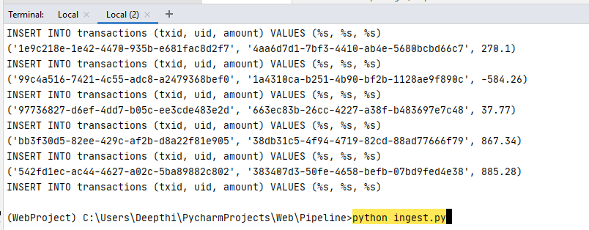

Verify data in Database:

